My 4-H
Cloverbud Record Book

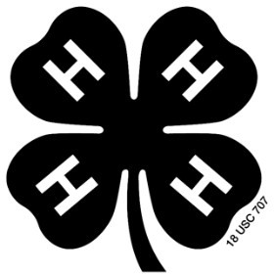

My Name:

Project Name:

Helper’s Name:

Dear 4-Hers and Helper,
This Project Record form is designed to help younger children record and recognize their accomplishments. Any help that a child receives from a helper is a very positive addition to the project and the form as long as the child is encouraged to do as much as possible themselves. If needed, the writing can be dictated to the helper. If more space is needed, add extra sheets of paper. Best of Luck!

Helper’s Signature 4-H Leader Signature

4-H Agent Signature

My 4-H Project Plan
(5-7 year old’s)

My Name: _ County:

Birthdate: ______________________________________ Age (as of 1/1/2019): __________________________

Address:

Club:

Parent/Guardian Name: _
Tell about your Project:
Example: My project is about a horses, I have my own horse and I ride it, clean up after it, and feed it.

What are some things you would like to learn while doing this project?
Example: I would like to learn to clean my horses hooves.

_

My 4-H Project Record

Things I learned and did in my project: Dates:
Example: I learned how much feed my horse needs every day. June 2018

What are other things that you did in 4-H or other places this year?
Example: I went to 3 Summer Fun Events I went to 5 club meetings
I joined scouts

_______________________________________________________________________________________

My 4-H Story

If you need extra space or want to write more you can use the back or add pages.

My favorite part of this project was:

_

The hardest part of this project was: _

_

I like being in 4-H because:

_

_

My Personal Touch/Mini Scrapbook
Attach special things like ribbons and pictures about your project. Draw a picture or write a story about what you did. (At least 3 pages).

